NAME: A.GopiRaj
REG. 192412453

Experiment: 6 5G NR Frame Structure Analysis with Different Subcarrier Spacing

Aim
To analyze the 5G NR frame structure by studying the effect of different subcarrier spacings,
slot durations, and OFDM symbols using MATLAB.
Objectives
1. To analyze different Subcarrier Spacing (SCS) values used in 5G NR numerology.
2. To compare the slot duration corresponding to different Subcarrier Spacing values in 5G
NR.
3. To study the number of OFDM symbols present in a 5G NR slot for normal cyclic prefix.

Objective – 1: Analyze Different Subcarrier Spacing Values
MATLAB Program
clc;
clear;
close all;
scs = [15 30 60 120 240]; % Subcarrier Spacing (kHz)
mu = 0:4; % Numerology Index
bar(scs)
grid on
set(gca,'XTick',1:5)
set(gca,'XTickLabel',mu)
xlabel('Numerology Index (\mu)')
ylabel('Subcarrier Spacing (kHz)')
title('5G NR Subcarrier Spacing for Different Numerologies')
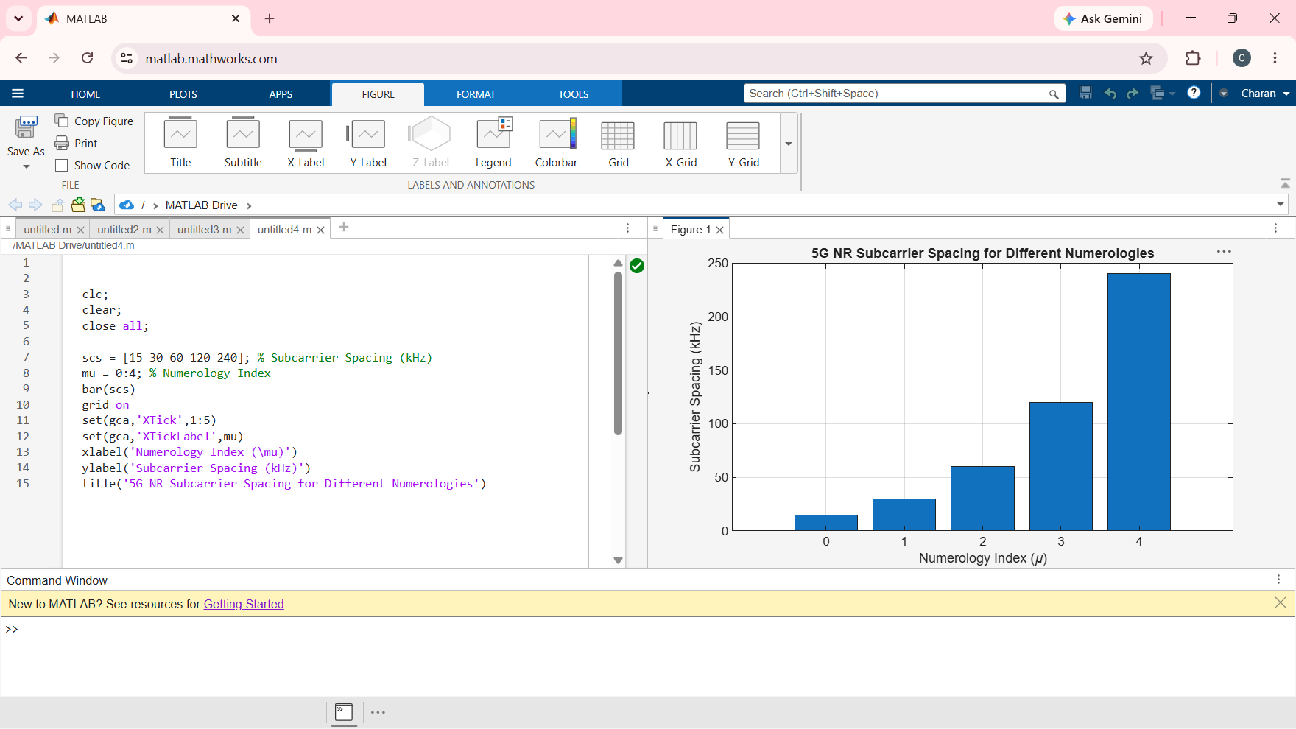
MATLAB Program
clear;
close all;
scs = [15 30 60 120 240]; % Subcarrier Spacing (kHz)
slot = [1 0.5 0.25 0.125 0.0625]; % Slot Duration (ms)
plot(scs, slot, 'o-', 'LineWidth', 2)
grid on
xlabel('Subcarrier Spacing (kHz)')
ylabel('Slot Duration (ms)')
title('5G NR Slot Duration for Different Subcarrier Spacing') 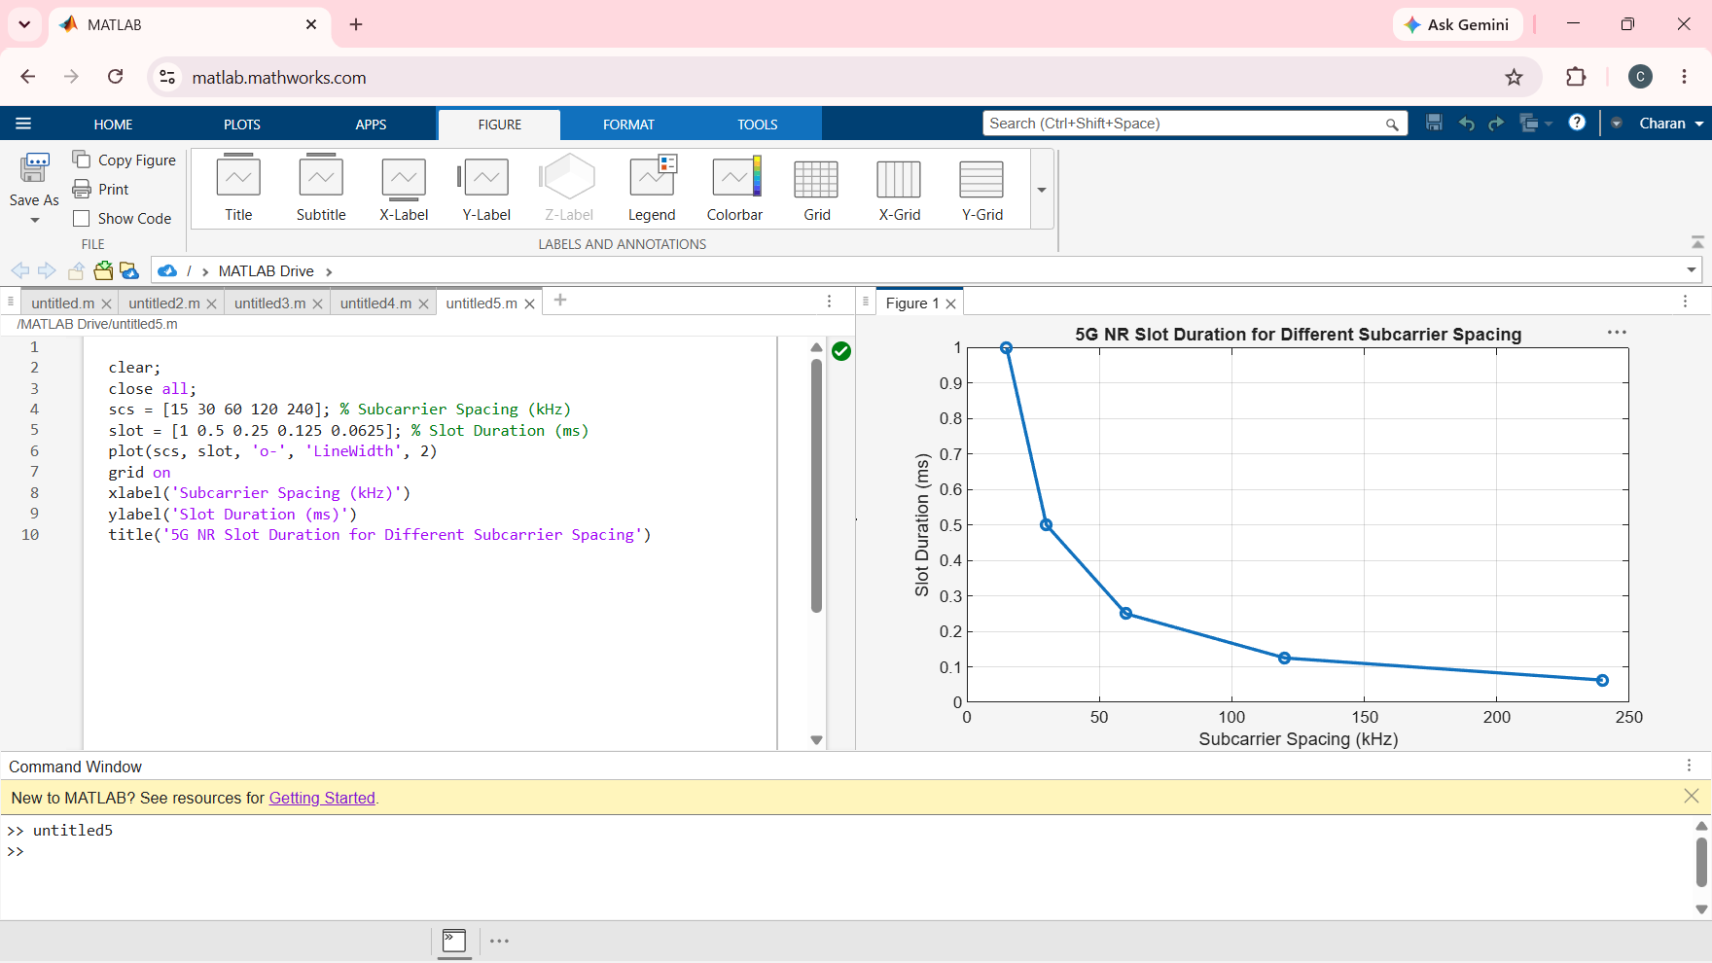
MATLAB Program
clc;
clear;
close all;
scs = [15 30 60 120 240]; % Subcarrier Spacing (kHz)
symbols = [14 14 14 14 14]; % OFDM Symbols per Slot
figure
bar(scs, symbols)
grid on
xlabel('Subcarrier Spacing (kHz)')
ylabel('Number of OFDM Symbols')
title('OFDM Symbols per Slot for Different Subcarrier Spacing')
ylim([0 16]) 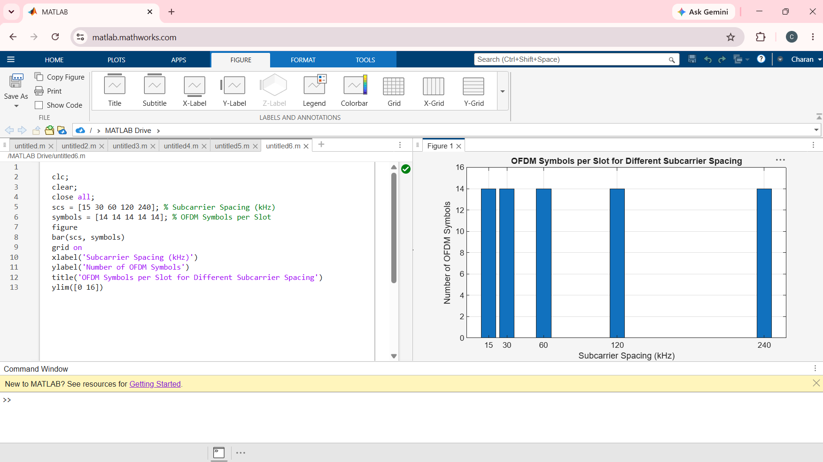

Result:
The MATLAB analysis successfully demonstrated the flexible numerology of 5G NR. The results showed that increasing the subcarrier spacing decreases the slot duration while maintaining a constant number of OFDM symbols per slot under the normal cyclic prefix configuration.

